Journal of the International Masonry Society, Masonry International, vol. XXX no. X, eXX, 2025
 | Masonry International  ISSN XXXX.XXX
ORIGINAL ARTICLE
Paper title
Author OneªORCID LOGO AND LINK
Author Two^{b}ORCID LOGO AND LINK
Author Three^{c}ORCID LOGO AND LINK

ªUniversity or Institution, Department, City, County, Country
^{b}University or Institution, Department, City, County, Country
^{c}University or Institution, Department, City, County, Country

Received XX May 2024  Revised XX July 2024  Accepted XX August 2024 | Abstract: An abstract of around 300 words should be the first section in Arial font size 8pt text. The page format is A4 portrait (width 21cm, height 29.7cm). Margins of: top 2cm; bottom 2cm; left 1.5cm; and right 1.5cm are to be used. Papers are to be prepared using Arial typeface and text is to be 1.5 times spaced. The main title, author and affiliations should be left-justified. The main title should be set in 18pt, the authors' names in 9pt, and the ORCID identification and affiliations in 8pt. The bulk of the text should be size 9pt and fully justified. Figure titles should be centred. Table titles should be left-justified. All papers must be written in English language. All units and abbreviations of dimensions, etc, should conform to SI standards. The Society style is N/mm², not MPa. Please ensure N/mm² is used, particularly on figures. The full text should not normally exceed 30 pages. This document may serve as a template for the preparation of the papers and authors are advised to copy or type their text directly into this document.  Keywords: authors may list up to 6 keywords in lowercase letters separated by commas.
Corresponding author: Author One Two or Three. E-mail: xx@xx.xx
Financial support: Type all funding information received making sure to include the funding source and grant numbers in that order. If you did not receive funding, state the following: None.
Conflict of interest: Type your author's conflict of interest statement after the colon. If all authors have nothing to declare add the following statement: Nothing to declare.
Data Availability: [Data Availability Statement Examples: “The data that support the findings of this study are openly available in [repository name] at [URL], reference number [reference number].”;” Data-sharing is not applicable to this article as no new data were created or analyzed in this study.”;” Due to the nature of this research, participants of this study did not agree for their data to be shared publicly, so supporting data are not available.”;” The data that support the findings of this study are available from the corresponding author, [author initials], upon reasonable request.”]
Copyright © 2025 International Masonry Society

How to cite: A. V. W. One, A. Two, and T. Three, “Title,” Masonry International, International Masonry Society, vol. XX, no. X, eXXX, 2025, https://doi.org/XX.XXXX/XXXXX-XXXXXXXXX

INTRODUCTION
State of the art, objectives, justification for this work and the significance are to be reviewed here. The organization suggestion has been adjusted to papers on experimental investigations; however, the authors can freely modify the sequence of items. The text must be written in 9pt Arial typeface. The maximum number of pages of the manuscript is 30, start counting from section “1 Introduction” and including acknowledgements and references. If it is necessary, you can divide the text sections into subsections using headings to clarify the text.

REFERENCES
References should be numbered in the order they appear in the text (i.e. NOT according to their alphabetical order) and should appear, fully justified, in the last section of the paper as in the example provided at the end of this document [1]. The initials of the first names should be written in uppercase, followed by the surname in lowercase letters. The title of the paper in lowercase. If it is a book, the title should be enclosed in quotation marksand followed by the publisher and place of publication. The name of the journal should be written in full, followed by the volume number. The issue number should appear in parentheses. This is followed by the page number(s) and date. If it is a conference paper, both the title of the paper and the title of the event should be enclosed in quotation marks. This should be followed by the location of the event, the date, the publisher's address, the publisher, and the initial and final pages of the paper. Private communications, unpublished work or restricted publications should not be quoted, but may be mentioned in the text. The Harvard method of referencing is also permitted as an alternative.

FIGURES, TABLES AND EQUATIONS

Tables
All tables appearing in the paper must be referred to in the text. Tables should be placed close to the text where cited. Table captions should be bold, written in 9pt, left-justified, and placed above the table. As an example, see Table 1.
Table 1. Summary of studies
Researcher(s) | Type | # | Method | Objective | Results
Smith el al. [1] | Precast | 2 | Linear | Cost | spacing of 2.75 meters
Taylor [2] | An example of longer text | 4 | Linear | Cost | spacing of 2.50 meters

The text inside the tables should be in Arial typeface, written in 8pt, with the possibility of using bold for emphasis.

Figures
All figures appearing in the paper must be referred to in the text. Colour figures may be photographs, graphs or drawings and should be placed close to the text where cited. Figure captions should be bold, should be in Arial typeface, written in 9pt, centred, and placed below the figure. As example, see Figure 1.
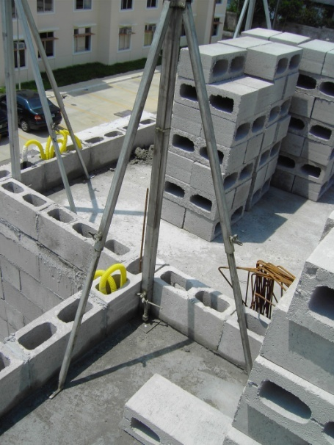
Figure 1. Example One
When the figure represents a graph, it must comply with the following specifications: all text should be set in 9pt, Arial typeface with automatic color. Axis titles must be in lowercase and bold. Legends should appear in lowercase. The graph must not include an internal title, as the figure caption is to be considered the official title of the graph. As example, see Figure 2.
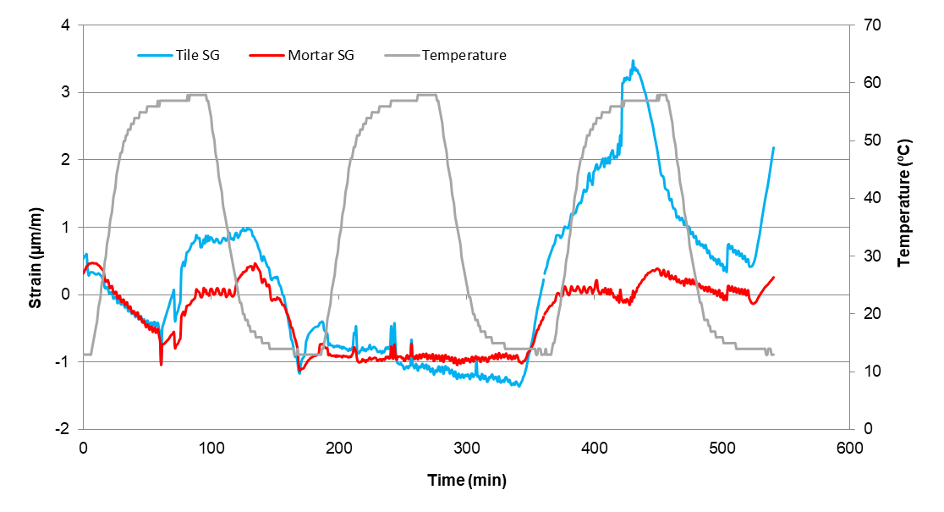
Figure 2. Example Two

Equations
Equations should be numbered with the equation appearing on the left and the number, in parentheses, appearing on the right with a line space above and below the equation. All equations should be referenced in the text. For example, see Equation (1) below:
𝒚𝒚 = 𝑭𝑭(𝒙𝒙) = [𝑓𝑓₁(𝒙𝒙), 𝑓𝑓₂(𝒙𝒙), … , 𝑓𝑓_{𝑚𝑚}(𝒙𝒙)] (1)

ACKNOWLEDGEMENTS
Acknowledgements may be made. The title should be without numbering, in upper case, bold and left-justified.

REFERENCES
- T.J. Smith, R.W Brown, A. White, Title of the Paper, Masonry International 25, (1), 8, 2012.
- H.F.W. Taylor, Chemistry of Cement, 2nd Ed, Thomas Telford, 1997, pp231-235.
- D. Hash, "On the," Ph.D. dissertation, University, London, United Kingdom, 2004. [Online]. Available: https://XXXX.
- M. A. Hasian and T. R. Loo, "Cost optimization," Can. J. Civ. Eng., vol. 3, pp. 41–89, 2001, http://dx.doi.org/10.15554/XXX.
- J.A. Silva and M.R. Costa, (2022). “Experimental analysis of lightweight concrete blocks under axial load”. In: “Proceedings of the 10th International Conference on Civil Engineering Materials”. São Paulo, Brazil, 5–7 October 2022. São Paulo: ABC Editora, pp. 123–130.

Author contributions: AO: conceptualization, development of the computational algorithm, data analysis, writing and translation; AT and ATE: supervision, revision.
Editors: XXX, XXX, XXX.

